Controlled Chaos: Automatic Parking Gate with Anti-Rush Sensing

Paleti Nikhitha Chowdary[1] [24110233] Pallav Biyala[1] [24110234]

1 Electrical Engineering, Indian Institute of Technology Gandhinagar, Gandhinagar-382355, India

Email: 24110234@iitgn.ac.in

***Abstract –* Rapid urbanization and growing vehicle numbers have led to increased traffic congestion and delays, especially at manual parking entry points. Inefficient gate management not only wastes time but also contributes to unnecessary queuing and security concerns. To tackle this, we propose an automated parking gate system using sensors and an Arduino to detect vehicles, operate the gate automatically, and provide real-time feedback—ensuring smoother traffic flow, reduced manual effort, and improved efficiency in parking management.**

***Index Terms – Traffic Congestion, Automated Parking Gate System, sensors, Arduino, Parking management***

I. INTRODUCTION

In India, the problem of parking has become a challenge on daily basis. Many a times, vehicles enter parking areas only to find that all slots are occupied, which results in traffic congestion, frustration, and a lot waste of time. Drivers may proceed all the way into the parking zone without any idea of availability, only to realize that there is no space left. By that time, several cars might have followed, making it difficult to reverse due to the rush. These very small issues can really affect a lot in our daily routines and can cause unnecessary stress. To tackle this, our team developed an Arduino-based system called **APGS (Automated Parking Gate System)**, which has aimed at ensuring smooth, human-free, and systematic parking.

The primary goal of APGS is to automate the gate operation — allowing cars to pass through without manual effort. To prevent parking rush, the system is designed to allow only one vehicle pass at a time, with a short delay before the next entry. This ensures the first car gets parked properly before the next arrives. With further upgrades, APGS can track the number of available parking slots and restrict access if parking is not available which would save a lot time of drivers.

II. DESCRIPTION OF PROTOTYPE

The circuit diagram for the prototype that we prepared is given below:

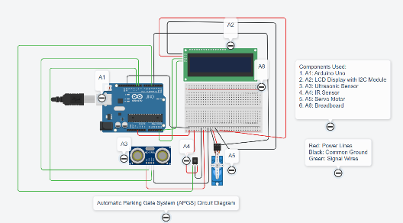

**Fig. 1: Circuit Diagram of Prototype**

Our prototype is composed of:

1. Arduino Uno
2. Ultrasonic Sensor (HC-SR04)
3. Servo Motor SG90
4. IR Sensor Module
5. 16 × 2 LCD Display with an I2C Module
6. Breadboard
7. Jumper Wires
8. 12V Battery

An Arduino Uno, Ultrasonic and IR Sensors were used to create the automated parking gate. An ultrasonic sensor positioned in front of the gate is used by the system to determine whether an automobile is present or not. If there is any car present, the ultrasonic sensor alerts the Arduino to activate the servo motor to open the gate when an automobile gets within 30 cm. To let the car through, a servo motor raises the gate arm.

The presence of a car beneath the gate is continuously monitored by an infrared (IR) sensor installed beneath it. As long as the IR sensor is blocked by the car, the gate remains open. The servo motor is told to return the gate to its closed position (0°) as soon as the IR sensor is unblocked, signifying that the vehicle has passed. To prevent instant reactivation, a 5-second cool down delay is applied after closing. This delay has been placed so that the ultrasonic sensor don’t allow servo motor to open gate immediately when next car comes. This is because this model is based on **Anti-Rush Sensing** concept and hence to avoid rush in the parking zone, we allowed the system to allow car to pass one by one. This ensures that there are not too many cars in parking zone.

III. RESULTS & THEIR ANALYSIS

The image of the APGS System formed can be shown in Fig.2 given below:

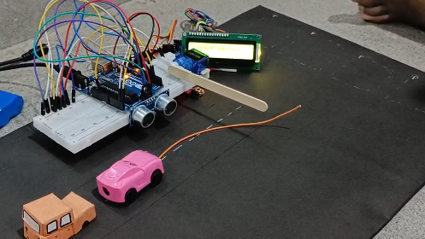

**Fig. 2: APGS System Model**

Following experiments were conducted many times to check if system is working properly or not:

1. The car approached the parking gate, triggering the ultrasonic sensor to open it. Once the car moved away, the gate closed, and LCD displayed 'Opening the Gate' upon entry and 'Closing the Gate' upon exit. Let’s see this experiment through the video given below:

<https://youtu.be/eWhm9yYNHYM?feature=shared>

1. Another experiment we did was that as soon as the gate opened, the car was left there within the gate. So, we let the car remain under gate and again as expected the gate didn’t close while screen showing “Car Under the Gate”. Arduino was coded such that if IR Sensor detects some object, the servo motor should not work. As soon as we removed the car, the gate closed. This experiment was done because there is a possibility that sometimes car do not start and in such case if gate closed, the driver could be injured.

Let’s see this experiment through the video given below:

<https://youtu.be/CX5hTl35koc?feature=shared>

1. The third experiment we did was with three cars. One car was allowed to pass to the gate while the other two cars was behind the first car. As soon as the car crossed the gate, the gate closed. Though the second car was being detected by the sensor, gate remain closed. This we did because we wanted no rush in the parking zone. One car at a time should park in the area and then after a short time interval, next car should come. This would make it more systematic and make our system **Anti-Rush Sensing.**

Let’s see this experiment through the video given below:

<https://youtu.be/qjcRHpFfRQA?feature=shared>

Through these experiments, the APGS system demonstrated its ability to:

* Automate gate control using sensors
* Ensure safety with IR-based detection
* Prevent congestion using a cool down delay
* Eliminate the need for manual monitoring

Thus, the system offered a practical solution for managing parking efficiently and safely.

IV. CHALLENGES: BUMPS IN THE LANE

Some of the challenges that we faced or could face in this system are:

1. The additional objective of our APGS system was to also help drivers know how many parking slots are available. We tried to perform it using two IR sensors but it was not working effectively. We kept in mind that if a car is entering system, we should subtract one from total slots available and if exiting add one to the slots available. Unfortunately, the experiment results were very uneven as sometimes it was not adding to available slots when a car exited or adding even when car was entering. So this bump couldn’t be crossed by our system. Our logic of using two sensors to count seemed to be correct but wasn’t working effectively.
2. One more bump that we found was that if the parking line would be very long, then it would take a long time for all cars to pass due to time delay. So, while our Anti Rush Sensing is efficient and safe, we realized it would be very time consuming in case a long line of cars is present and there are too many slots available.
3. A small bump that we experienced during the preparation of our circuit model was we were using too many electric components, and using just Arduino’s 5V to power it up. We didn’t realize this due to which servo motor and LCD Display weren’t working properly. Later, from lab staff we got to know that we would need a 12V battery to overcome this bumper.

Hence, with future upgrades, our APGS System would be able to solve these challenges too.

V. CONCLUSIONS

This project successfully automated a parking gate. The gate's safe and responsive operation was made possible by the integration of IR and ultrasonic sensors. An LCD display successfully delivered real-time feedback, making the system easy to use.

The project is a powerful illustration of how basic parts can be put together to form intelligent and useful systems. This model could be expanded to commercial parking solutions with additional enhancements like RFID access or mobile app integration. To sum up, the automated parking gate is a useful and expandable addition to contemporary access control systems. With future upgrades, it would be able to even have the ability of counters and the sensing of allowing cars to go in case line is too long.

VI. REFERENCES

The references and tools that have helped to prepare this report and support it are:

[1] “Automatic Parking Gate System (APGS) - Prototype Demonstration,” YouTube, Apr. 2025. Available: <https://youtu.be/O7yoa-hwnkI?feature=shared>

[2] Autodesk to develop circuit, “Tinkercad | From mind to design in minutes,”. Available: <https://www.tinkercad.com>

[3] “Top 10 Benefits of Smart Parking Protection and Why You Should Use It,” Smart Parking Solutions. Available: [Top 10 Benefits of Smart Parking Protection And Why You Should Use It](https://parklio.com/en/blog/top-10-benefits-of-smart-parking-protection-and-why-you-should-use-it)

[4] “APGS System Simulation” YouTube, Apr. 2025. Available: <https://youtube.com/playlist?list=PLvjoIOhPzRH5EloviU5a_IpTimhs7s1a6&feature=shared>